ENGR 200 FALL, 2017

**A4: COMPUTING WATER TANK LEVELS**

**(using input/output data files, a for loop, if structures, and a user-defined function)**

DUE: Oct. 3, 2017 at 11:59 PM, CDT POINTS: 50

**INTRODUCTION:**

A municipal water tank has a shape as shown to the right. There is a float inside the tank that can transmit the water levels to the city office. Float level data has been collected for one week and placed in a file called **water_level**.

rw

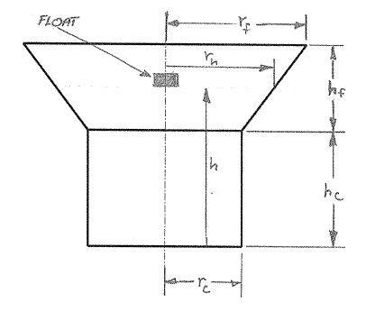

The city needs an automated system that will alert city officials when the water level is too low or too high, and when the water level is good. Since the shape of the tank has two distinct parts (a cylinder and an inverted frustum), two volumetric equations are needed.

The water volume of the cylindrical portion is computed by:

$V_{c}=πr_{c}^{2}h$

Where rc is the radius of the cylinder and h is the height of the float.

The total water volume of the tank (cylinder + frustum) is computed by:

NOTE: Define pi as a symbolic in the preprocessor directive section of the program.

$V_{cf}=πr_{c}^{2}h_{c}+\frac{1}{3}π(h-h_{c})(r_{c}^{2}+r_{c}r_{w}+r_{w}^{2})$

Where h is the height of float, hc is the height of the cylinder, rc is the radius of the cylinder, and rw is the radius of the water in the frustum.

The radius of the water in the frustum is computed by:

NOTE: All variables must be appropriate variable names. No single letter variables are allowed in your program.

$r_{w}=r_{c}+\frac{10.5}{h_{f}}(h-h_{c})$

**ASSIGNMENT:**

Write a C program that will read the radius and height of the cylinder, the radius and height of the frustum, the control number, and the float heights. The first record line of the input file is comma delimited. The remaining record lines in the input file are single numbers so a file delimiter is not needed. The main function of the program will pass the radius of the cylinder, the height of the cylinder, the height of the frustum, and the float height to a user-defined function. The user-defined function will compute the volume of water in cubic meters in the tank. The computed volume will be passed back to the main function.

In the main function use a **for** loop to read the float heights from the input file and test for the following conditions:

* If the float height data is less than 0.0 meters print the message:

**Height negative-Calibrate float.**

* If the float height data is greater than the cylinder height plus the frustum height print the message:

**Height > xx.x meters-Calibrate float.**

* If the float height data is equal to 0.0 meters or the float height is less than 3.0 meters print the message:

**Height < 3.0 meters-Fill tank.**

* If the float height is greater than or equal to 3.0 and the float height is less than or equal to the cylinder height

plus the frustum height, call the user-defined function to compute the water volume and upon return print the

float height and the water volume computed by the user-defined function.

In the user-defined function where the water volume is computed test for the following condition:

* If the float height data is greater than or equal to 3.0 and the float height is less than or equal to the cylinder height, then compute the water volume in the cylinder, else compute the total water volume contained in the water tank.

The results will be printed to the computer screen and to an output data file called **water_volume**. The format for the output is given below.

**OUTPUT FORMAT:**

*************************************************

CITY WATER SUPPLY PROGRAM

Water tank dimensions:

Cylinder radius = xx.x meters

Cylinder height = xx.x meters

Frustum radius = xx.x meters

Frustum height = xx.x meters

Float Height Water Volume

(meters) (cubic meters)

xxx.x xxxxx.xx

. .

. .

. .

xxx.x Print appropriate message.

. .

. .

. .

xxx.x xxxxx.xx

END OF REPORT

*************************************************